* **Section 1.1** – Project description, project management style used, potential users, maybe some other stuff
* **Section 1.2** – Preliminary project requirements; these can be formalized as an SRS or can be a list of user stories. Try to break the project up into a CSCI breakdown. Note that this is a *LIVING DOCUMENT* which you will need to update at several stages of the development.
* **Section 1.3** – Preliminary design description, including diagrams and text explanations.
* **Section 1.4** – Preliminary development schedule; this just needs to be a basic idea of what parts will be developed in what order, and a SWAG at what will be in each iteration. Since you don't know all the details at this point, the focus should be on the functional decomposition of the project and a first shot at what might be done together as part of a single MVP.
* **Section 1.5** – Development tools, which is just a listing of what software you'll need to use to develop your project.

**1.1**

Project Description:

The project is about creating a database of car sales information of a car dealership company. It includes salespersons, their unique employee ID, customer name and details, car make and model, and many other details that are usually included with car buying.

Project Management Style: Agile Project Management methodology will be used to complete this project. Kanban and Scrum tools will also be utilized to increase the efficiency of completing the project.

Potential Users: Car Dealers are the potential users

**1.2 System Features and RequirementsL**  
 1.2.1  Functional Requirements

1.2.1.1  Users shall be able to access database through a search engine.

1.2.1.2  Users shall be able to input, delete or archive data.

1.2.2  User Interface Requirements

1.2.2.2  Back-end software: aws

1.2.2.3  Database software: tableplus

1.2.3  Hardware Interface Requirements

1.2.3.1  System shall interface with both Mac and Windows operating system through their default web browser

1.2.4  System Features

1.2.3.1  The database shall be able to store 100,000(??) distinct data points

1.2.3.2  The database shall load and be usable within 3 seconds

1.2.3.3  The database shall update the interface on interaction within 2 seconds

1.2.3.4  The database shall be normalized to prevent redundant data and improve performance

1.2.3.5  The database should be distributed to prevent outages

1.2.3.6  Backups of the databases should be done hourly and be kept for one week

1.2.3.7  The databse shall be available 95% of the time

**1.3** Base ER diagram to start

Project Description: As stated our project will revolve around a basic car dealership database. The data will most likely flow as show below. We will be started with a build of car purchases and may expand to services based on how long it takes us to design the schema.

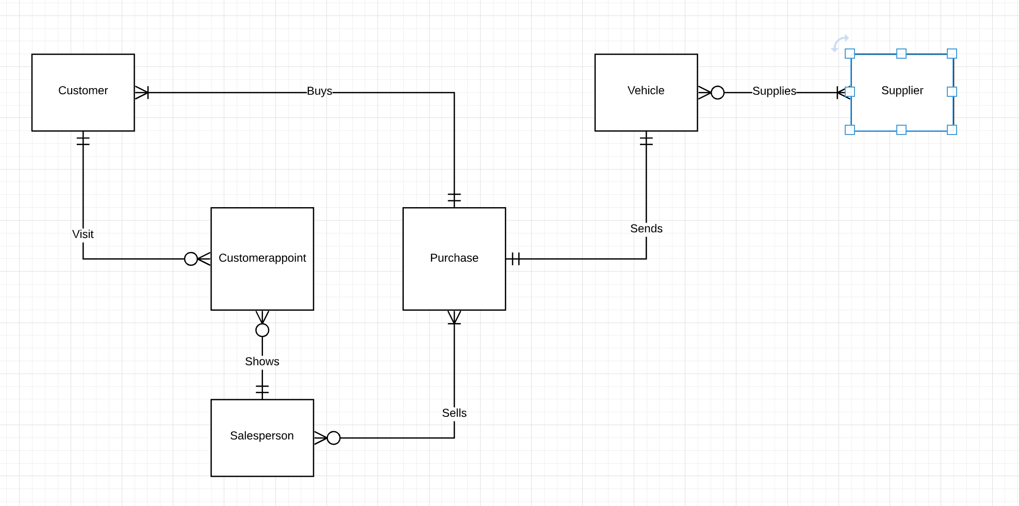

**1.4**

MVP – We want a database that employees can semi interact with but still have to query through with SQL, at this point our relationships would be developed, but we still would need to pull more customer data and set up some complex queries.

Week 0: 01/21

Schema build

Week 1: 02/02/21

Research

Preliminary Data Writing

Week 2: 02/09/21

Querying and Testing

Optimization

Week 3: 02/16/21

User input

Customer Search functionality

Week 4: 02/21/21

Intractability testing

Finish 2.1-2.5

Reassess

**1.5**

Scrum application (trello board)

PSQL

MYSQL

Oracle

Table Plus/Access

JSON/Python